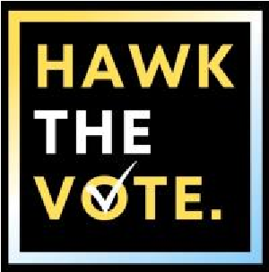
Office of Leadership, Service, and Civic Engagement
Position Description

Communications Director – Hawk The Vote
Hawk The Vote is seeking a part-time, stipend-paid executive board position for the 2026 calendar year. This position will work in conjunction with the Office of Leadership, Service, and Civic Engagement to organize politically focused events and voter registration drives. Compensation will be a $3,000 stipend awarded monthly between February 1st, 2026, and January 1st, 2027.
Positions Requirements
- Must be a current University of Iowa undergraduate student.
- Will not graduate in Spring 2026 or Fall 2026.
- Be able to dedicate 5-8 hours per week to a position with Hawk The Vote:
  - Attend weekly executive board meetings.
  - Complete 1 tabling events per month, excluding May, June, and July.
  - Attend all other official Hawk The Vote events at the discretion of the Executive Director.
- Remain nonpartisan in all official work with Hawk The Vote.
Positions Expectations
- The Communications Director is responsible for all external imagery, social media, and outreach to the student body and Iowa City community.
- Key responsibilities:
  - Curate content for the organization’s social media accounts.
    - Advertise events organized by the Programming/Education Director.
    - Develop candidate guides for all federal, state, and local elections relevant to the University of Iowa.
  - Create a strategic communication plan each calendar year.
    - Oversee the organization’s brand.
  - Oversee the coverage of USG elections*
  - Respond to press and media inquiries in a timely manner.

*If you wish to run for USG President, Vice President, or At-Large Senator in Spring 2026, this responsibility will be delegated to the Executive Director.

